Collect and use data to safely end containment

Introduction

Our world is facing a Covid-19 epidemic caused by the new coronavirus SARS-Cov-2. As a consequence, more than 3 billionpeople4, including Swiss, are currently confined in order to slow the spread of the virus. This measure aims to avoid saturation of medical institutions and to stall by the time that a vaccine or cure can be found. Notwithstanding, containment is not a durable solution if it is not followed by a well-thought-out un-containment: a few months of isolation might end up being completely useless if the virus is still present in the population and starts spreading once again.

Therefore, this leads to important questions. What regions should be freed first ? How can we target the tests in order to use them wisely as their number is limited? What are the risks that the behaviors you adopted during the containment put you in contact with the virus ? Being able to target who to free first and who to test is a key knowledge to ensure an effective and hopefully unique un-containment phase.

The survey

To achieve this, a survey seems a useful tool to allow the Swiss Confederation to have a better understanding of the **contamination by Covid-19 of its population**. This allows a more **intelligent and targeted use of the limited tests**.

The survey is divided into four parts. The first one is about **personal informations**. The person’s Canton3 and whether or not he or she is working from home is additionally asked to evaluate the contamination risk. Finally, the proportion of the job that can be done from home in asked in order to evaluate any economical risk of the containment of the individual. The next part of the survey concerns **Covid-19 testing**. This is whether or not the individual has done a Covid-19 test or has been tested positive by a Doctor. It leads to evaluating whether the person is immune or still sick. The following part asks about **household and hygienic measure**. This is divided into three main parts: evaluation of the individual’s sanitary actions1 (hand washing, laundry, sneezing and coughing in elbow, and hugging/shaking hands), the possible Covid-19 specific symptoms and whether or not he or she is confined alone. This last part is important as the more people live together, the higher the contamination risks. The possible symptoms of family members are also evaluated. Additionally, the risk of being an immune person is evaluated. The most specific Covid-19 symptoms1 are loss of olfaction and taste and shortness of breath. Others symptoms1 are headache, fever, cough, sore throat, aching muscles and/or joint, nasal congestion/runny nose and diarrhea. Finally, the last part learns about **possible risky social contacts outside the household**. Those include public transports, grocery shopping and physical contacts with possibly infected people. These can be seen in the schemes below, Figures 1 to 4.

Figure 1

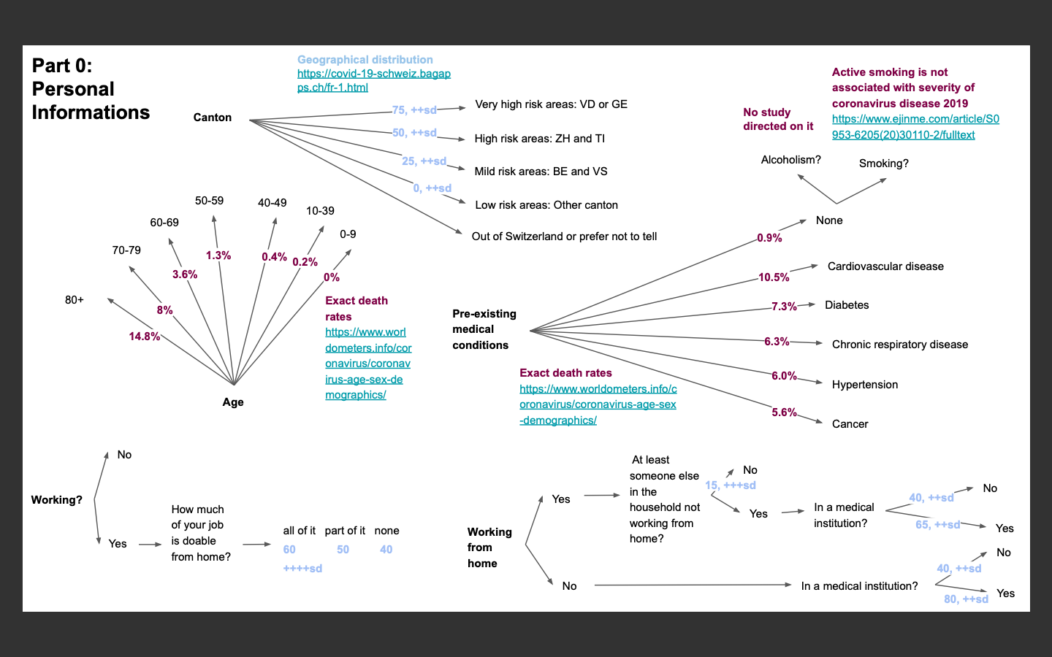

Figure 2

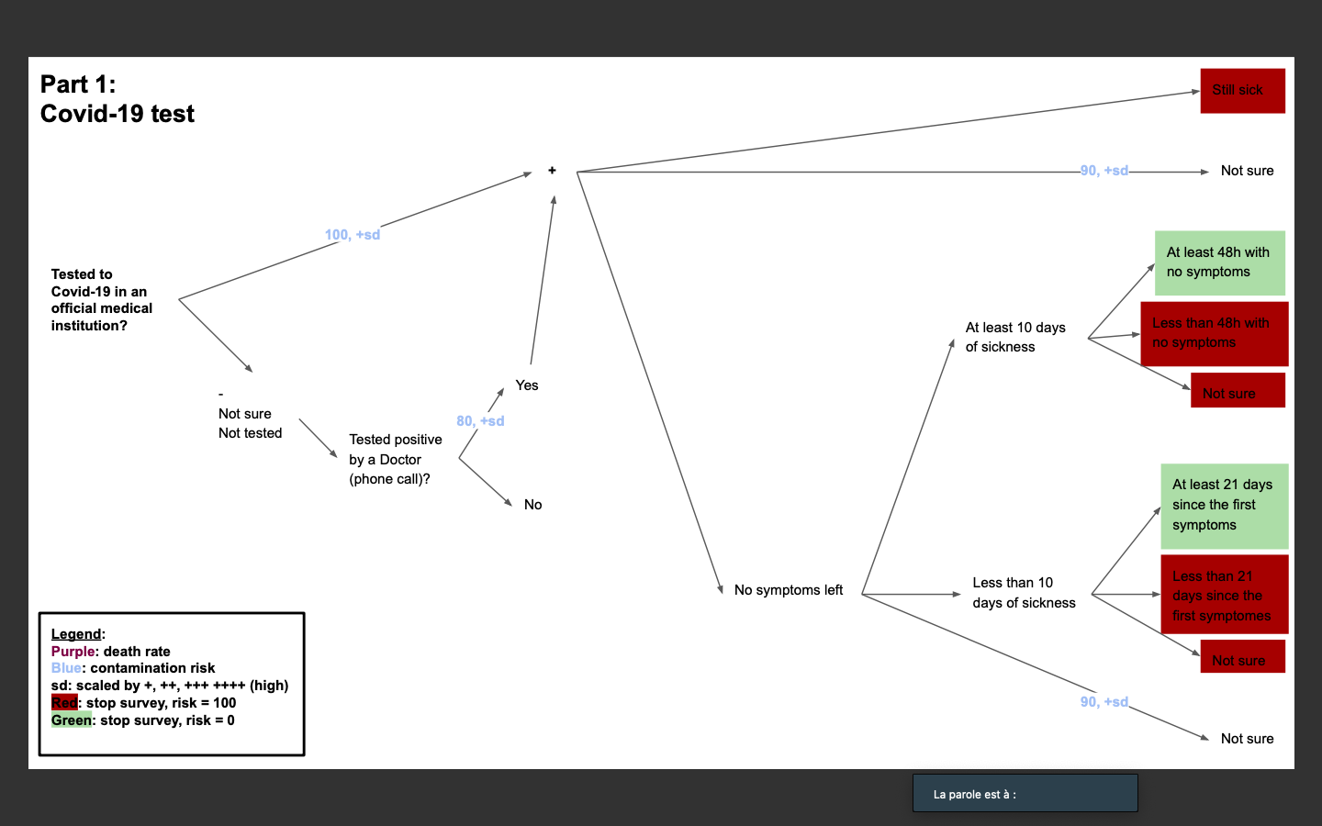

Figure 3

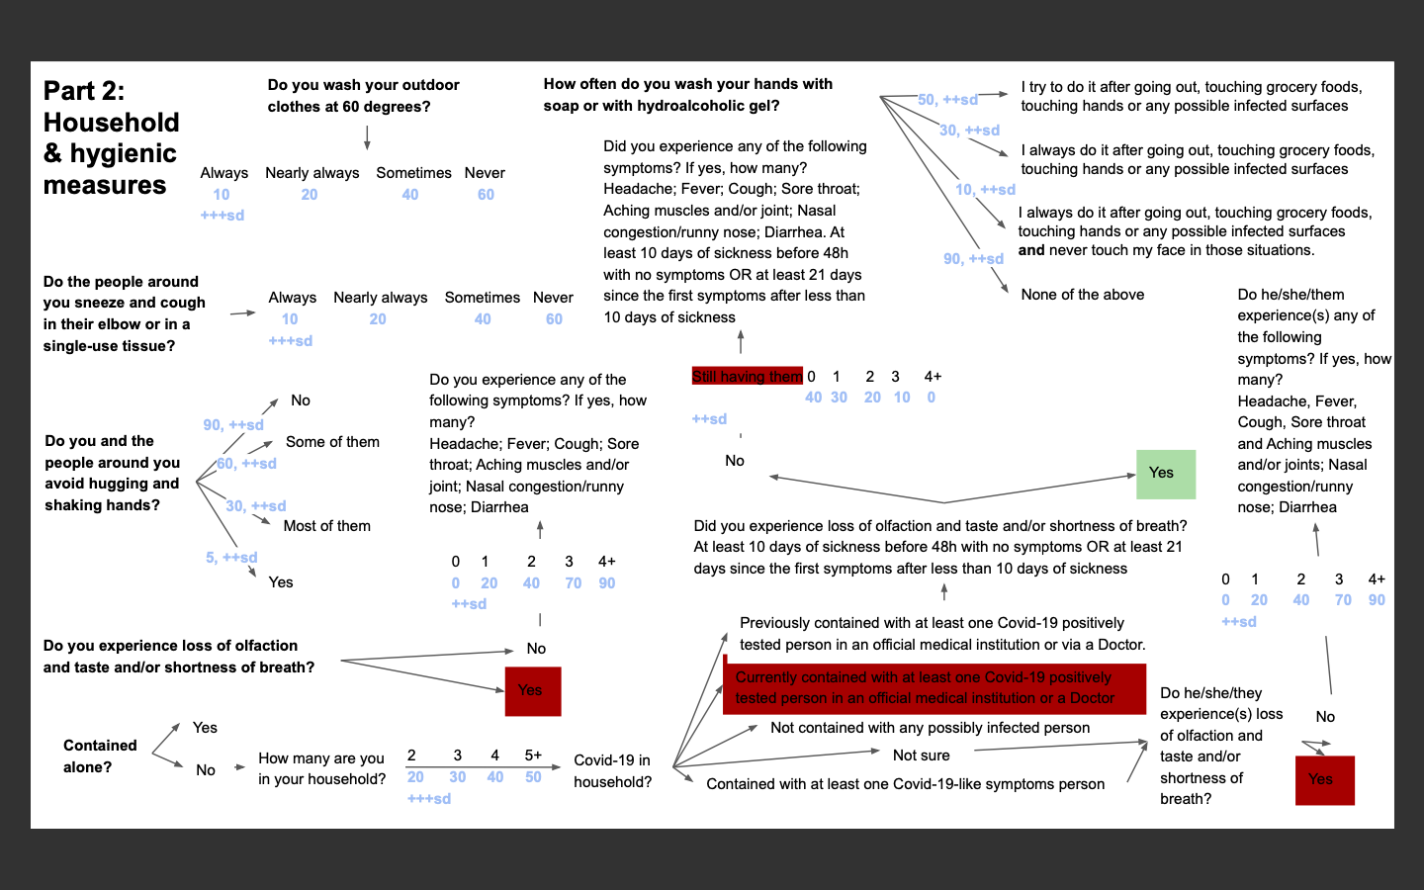

Figure 4

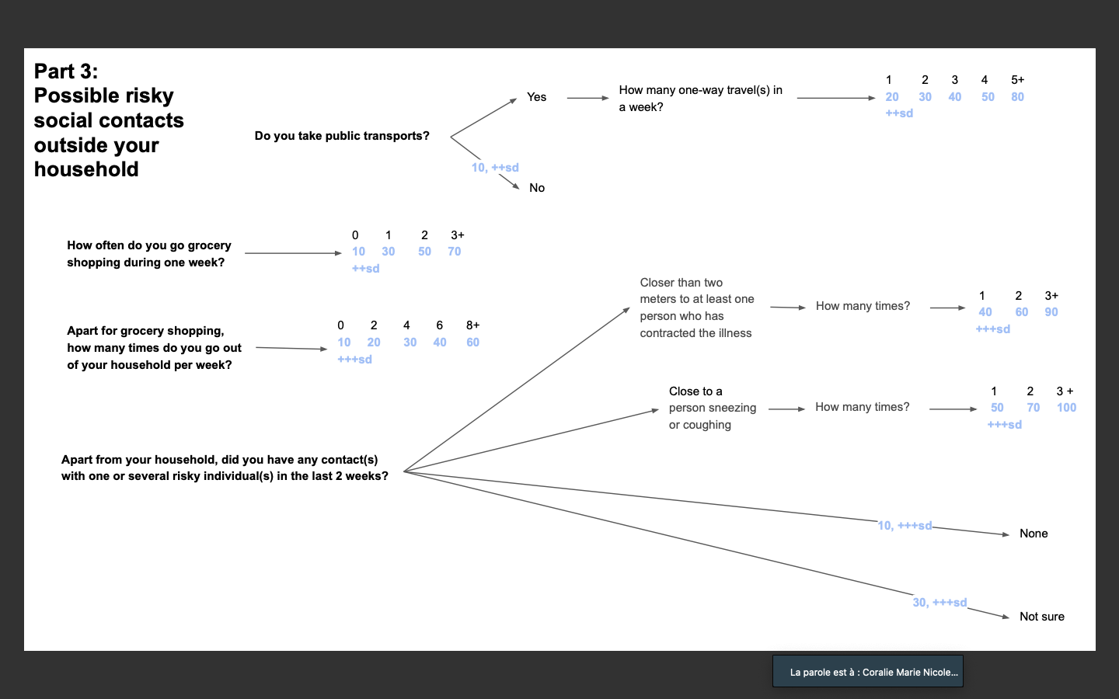

Computing Gaussian probabilities

On a percentage scale from 0 to 100, 10 categories are chosen, ie. Category 1: “not at risk”, Category 4: “moderate risk person”, Category 8: “You are strongly advised to remain confined” and Category 10: “person at risk”.

For each answer of the questionnaire an average risk score was define.

After each question, each category will have this score added according to the Gaussian form (mean and standard deviation defined in relation to the question). The added score corresponding to the image of the mean abscissa of the category, for example, for category 1 corresponding to the interval 0-10 we will take the value in 5.(cf Figure 1)

*To each answer is associated a Gaussian probability. The mean of this Gaussian probability is determined has an estimated risk on a 1 to 10 scale, 1 being the lowest risk score and 10 being the highest, in case you are known to be sick for example.*

The standard-deviation of the Gaussian probability is determined based on different criteria (cf Figure 2)

- **The reliability of the response**. Some answers might depend on the person personal evaluation, which may vary between people. *For example, "Do you wash your hands: Always/Some/Never".*

- **The knowledge of the impact of a certain interaction**. For example, even if it is proved that shaking hands increases the risk of getting infected, there are no data that can really allow quantification of such an interaction, which therefore requires a higher standard-deviation.

- **The influence of an interaction on the increase or decrease of the risk of getting infected.** Interactions that play a higher responsibility in the transmission of the virus have lower standard deviation that the ones playing a less important role. Since the final result is based on a probability of belonging to a certain at risk population, this way of giving or not importance to a certain interaction was chosen rather than giving a ponderation coefficient to the interaction, because the overall impact on the final result remains roughly the same.

Gaussians was considered to be the best method to evaluate the risk of contaminating its environment. Since data were missing, it was not possible to quantify perfectly the effective probability of each interaction mentioned in the survey.

Moreover, the choice of a normal law had an interest in its stability by simple addition.

Finally, the Gaussian allows each event to have a more or less weighted score for each category.

At the end of the study, the category with the highest score will correspond to the situation of the individual completing the questionnaire.

Figure 5:

Score by categories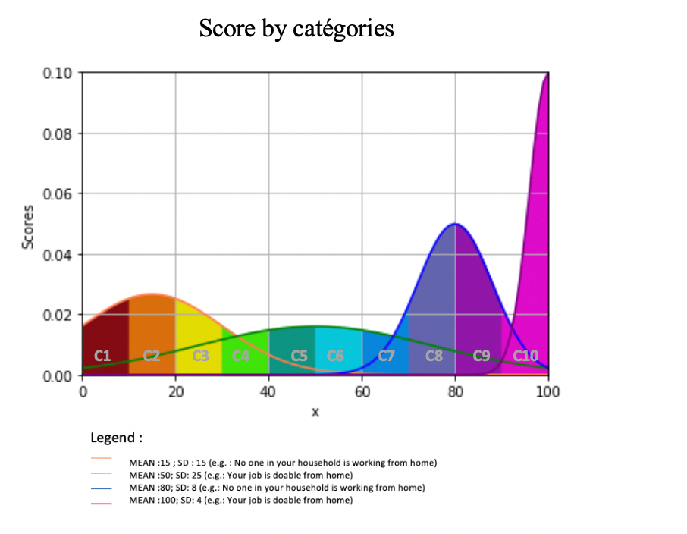

Figure 6:

Standard deviation used

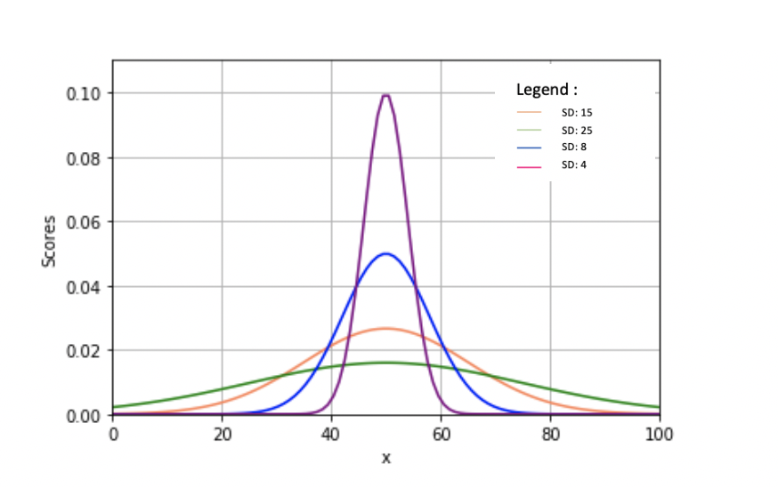

Results

The result is given as a graph. The x-axis is the 1 to 10 risk scale; while the y-axis is the percentage of your total score that you belong to the corresponding risk integer.

to a integer from 1 to 10, added to a. The integer is the scale risk in which you are the most likely to belong to. Eventually, the given result corresponds to the

Conclusions

dd

References

1The World Health Orgaization, <https://www.who.int/>

2

3The Swiss Confederation, <https://covid-19-schweiz.bagapps.ch/fr-1.html>

4Le Monde, <https://www.lemonde.fr/planete/article/2020/03/29/le-coronavirus-dans-le-monde-trois-milliards-de-personnes-confinees-trump-renonce-a-placer-new-york-en-quarantaine_6034798_3244.html>